**LAB 06 RECURSION AND ABSTRACT DATATYPES**

1. Create a program that recursively searches for files with a specific extension in a given directory.

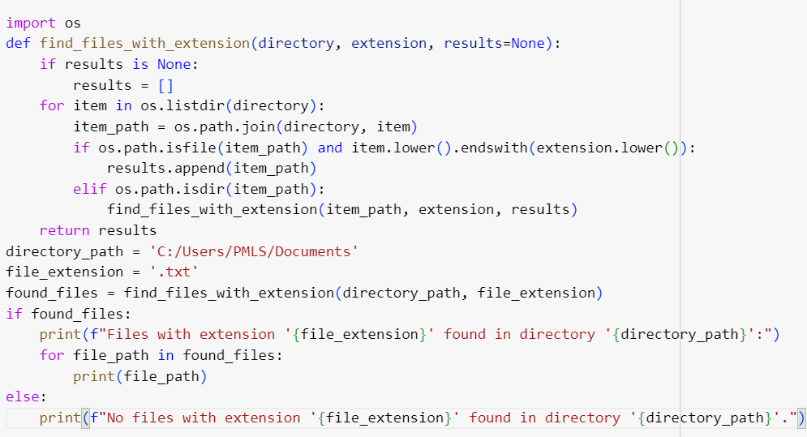

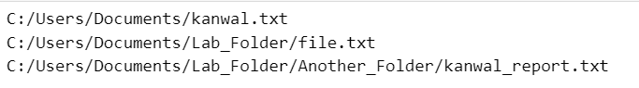

(2) Implement Fibonacci series using recursive function.

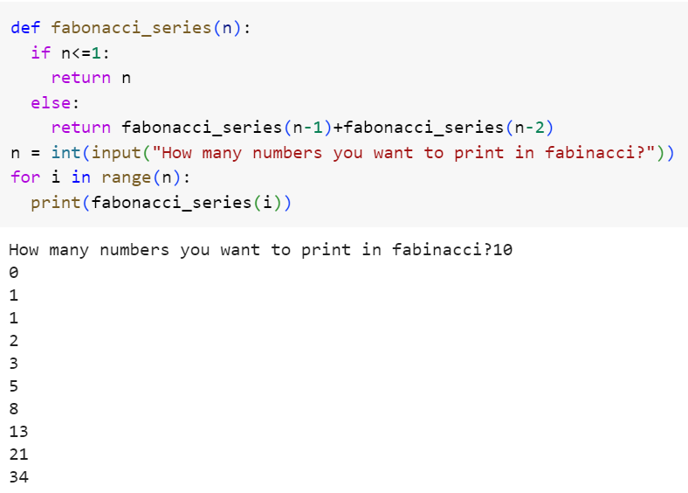

(3) Implement Undo Mechanism Using Appropriate ADT

(4) You are working on a social network analysis project and need to implement various set operations to analyze relationships between users.

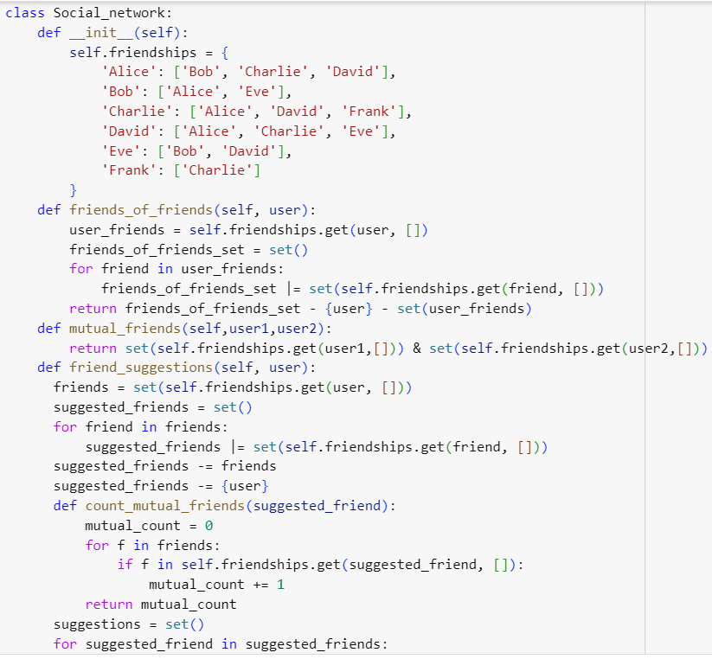

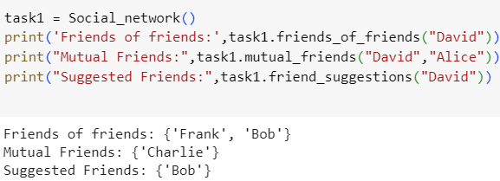

(5)Implement a gradebook analysis program using the Map ADT. The program should read a CSV file containing student names and their corresponding grades. The CSV file will have two columns: "Student Name" and "Grade".

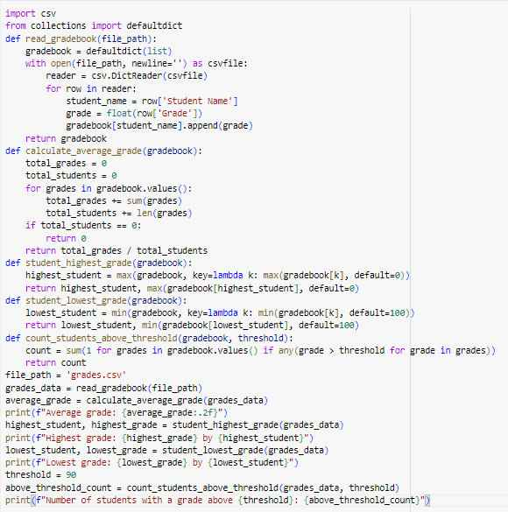

1. Identify ADT used in Print Job Management and implement its code as well.

